**Interactive Dashboard Using Python Flask,MongoDB, and Javascript**

COMPANY MASTER DATA (Source: <https://data.gov.in/>)

I have used MongoDB for storing and querying the data, Python for building a web server that interacts with MongoDB and serving html pages, Javascript libraries d3.js, dc.js and crossfilter.js for building interactive charts.

For building the charts, I have used 3 Javascript libraries: [crossfilter.js](http://square.github.io/crossfilter/), [d3.js](http://d3js.org/) and [dc.js](http://dc-js.github.io/dc.js/).

* [crossfilter.js](http://square.github.io/crossfilter/) is a Javascript library for grouping, filtering, and aggregating large datasets.
* [d3.js](http://d3js.org/) is a Javascript library for controlling the data and building charts.
* [dc.js](http://dc-js.github.io/dc.js/) is a Javascript charting library that leverages both crossfilter.js and d3.js, and makes the creation of highly interactive data visualization simple.

Mongodb Connection

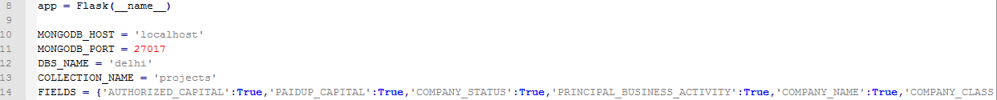C:\Users\Prarit\Documents\startup\dashboard\Mongodb1.PNG

.defer is for reading the projects dataC:\Users\Prarit\Documents\startup\dashboard\crossfilter.PNG

Creating a Crossfilter instance.

C:\Users\Prarit\Documents\startup\dashboard\Database.PNG

Defining 5 data dimensions, namely Authorized Capital, Company Class, Principal Business Activity, Company Status, and Company Name



Defining Data groups:

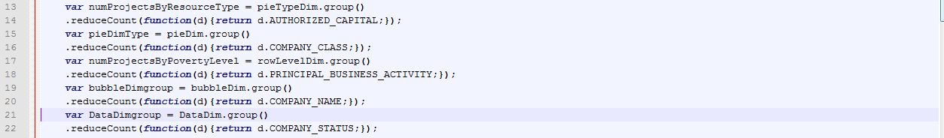

Defining DC Charts:



Dashboard Screenshot

